附件2
Impact of Gallic Acid on Gut Health: Focus on the Gut Microbiome, Immune Response, and Mechanisms of Action

Kang Yang¹, Limeng Zhang¹, Pinfeng Liao¹, Zaili Xiao¹, Fan Zhang¹, Daniel Sindaye¹, Zhongquan Xin¹, Chengquan Tan¹, Jinping Deng¹, Yulong Yin¹,²* and Baichuan Deng¹*

¹ Maoming Branch, Guangdong Laboratory for Lingnan Modern Agriculture, Guangdong Provincial Key Laboratory of Animal Nutrition Control, National Engineering Research Center for Breeding Swine Industry, College of Animal Science, South China Agricultural University, Guangzhou, China
² National Engineering Laboratory for Pollution Control and Waste Utilization in Livestock and Poultry Production, Key Laboratory of Agro-ecological Processes in Subtropical Region, Institute of Subtropical Agriculture, Chinese Academy of Sciences, Changsha, China

*Correspondence:
Yulong Yin
yinyulong@isa.ac.cn

Baichuan Deng
dengbaichuan@scau.edu.cn

Abstract
Gallic acid (GA) is a naturally occurring polyphenol compound present in fruits, vegetables, and herbal medicines. According to previous studies, GA has many biological properties, including antioxidant, anticancer, anti-inflammatory, and antimicrobial properties. GA and its derivatives have multiple industrial uses, such as food supplements or additives. Additionally, recent studies have shown that GA and its derivatives not only enhance gut microbiome (GM) activities, but also modulate immune responses. Thus, GA has great potential to facilitate natural defense against microbial infections and modulate the immune response. However, the exact mechanisms of GA acts on the GM and immune system remain unclear. In this review, first the physicochemical properties, bioavailability, absorption, and metabolism of GA are introduced, and then we summarize recent findings concerning its roles in gastrointestinal health. Most importantly, the thesis set out to review the available information and seeks to explain how GA influences the GM and modulates the immune response to maintain gastrointestinal health.

Keywords: polyphenol, gallic acid, gut microbiome, immune response, gastrointestinal health.

INTRODUCTION

Gallic acid (GA), 3,4,5-trihydroxybenzoic acid, is a polyphenol compound (1) and has gradually won a considerable amount of attention because it is ubiquitous in fruits, vegetables, and herbal medicines, such as grapes (2-4), gallnuts (5, 6), pomegranates (7, 8), and tea leaves (9, 10).

PHYSICOCHEMICAL PROPERTIES OF GA

Frequently, polyphenols are mainly divided into two categories, including flavonoids (anthocyanins, flavanols, flavanones, flavonols, flavonones, and isoflavones) and non-flavonoids (phenolic acids, xanthones, stilbenes, lignans, and tannins).

BIOAVAILABILITY, ABSORPTION AND METABOLISM OF GA

It has been widely claimed that polyphenols are good source of natural health products and are beneficial for human health (51-55).

GA IN GASTROINTESTINAL HEALTH AND DISEASE

Over the past decade, researchers have provided plenty of emerging evidence that the GM plays a crucial role in the maintenance of physiological homeostasis within the GIT, and microbiome dysbiosis is directly related to many health problems, such as gastrointestinal disease. Several studies in animal models investigate the effects of GA consumption on gastrointestinal diseases and its mechanisms of action.

Gastric Cancer
GA has potent therapeutic effects on the nonsteroidal anti-inflammatory drug (NSAID)-induced gastropathy.

Colorectal Cancer
Colorectal cancer (CRC) has the third highest cancer incidence around the world, and it constitutes a major global health burden threatening public health (79).

Inflammatory Bowel Disease
Inflammatory bowel disease (IBD), including Crohn’s disease (CD) and ulcerative colitis (UC), has long been doubted to correlate of an abnormal host reaction to GM (87).

EFFECTS OF GA ON THE GM

The GM is a key modulator of human health (94, 95). It is a complex ecosystem that varies between individuals (96).

Antimicrobial Properties In Vitro
GA has broad-spectrum therapeutic properties including antibacteria, antifungal, and antiviral activities in vitro (Table 1).

Action of GA on the GM in Animals and Humans
Most plant-derived polyphenols must be transformed through the GM and intestinal enterocyte enzymes to be absorbed at enterocyte and colonocyte levels.
GA IN IMMUNOMODULATION

The gut is an immune organ in which more than half of all immune cells are concentrated. The gut immune system linked to obesity, diabetes, food allergies, and IBD (143), thus, the gut immune function is closely related to human health.

CONCLUSION AND OUTLOOK

This review summarizes the physicochemical properties and bioavailability of GA, and reports related to the impact of GA on gastrointestinal health focus mainly on GM, immunomodulation and mechanisms of action.

CONFLICT OF INTEREST

The authors declare that they have no known competing financial interests or personal relationships that could have appeared to influence the work reported in this paper.

AUTHOR CONTRIBUTIONS

KY generated ideas and wrote the initial manuscript. YY and BD guided and revised the manuscript. CT and JD made feasible suggestions for the manuscript. LZ, P L, ZX, FZ, DS, and ZX contributed to the collection and arrangement of literatures.

FUNDING

This project was supported by ……

REFERENCES

1. National Center for Biotechnology Information. PubChem Database. Gallic acid, CID=370, https://pubchem.ncbi.nlm.nih.gov/compound/Gallic-acid (accessed on Oct. 21, 2019).
2. Cedó L, Castell-Auví A, Pallarès V, Macià A, Blay M, Ardévol A, et al. Gallic acid is an active component for the anticarcinogenic action of grape seed procyanidins in pancreatic cancer cells. Nutr Cancer. (2014) 66:88-96. doi: 0.1080/01635581.2014.851714
3. Ferruzzi MG, Lobo JK, Janle EM, Cooper B, Simon JE, Wu QL, et al. Bioavailability of gallic acid and catechins from grape seed polyphenol extract is improved by repeated dosing in rats: implications for treatment in Alzheimer's disease. J Alzheimers Dis. (2009) 18:113-24. doi: 10.3233/JAD-2009-1135
4. Scoccia J, Perretti MD, Monzón DM, Crisóstomo FP, Martín VS, Carrillo R. Sustainable oxidations with air mediated by gallic acid: potential applicability in the reutilization of grape pomace. Green Chem. (2016) 18:2647-50. doi: 10.1039/c5gc02966j

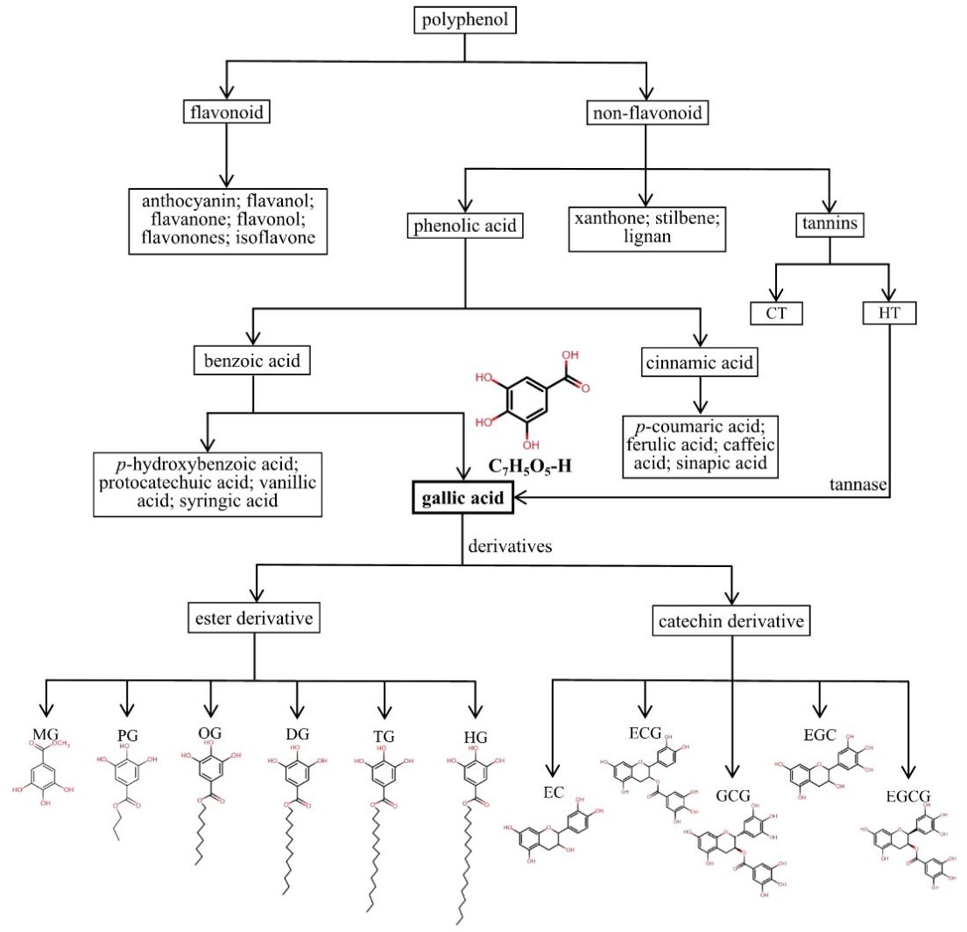
FIGURE 1 | Detailed classification and chemical structures of polyphenols, phenolic acids, GA and its derivatives. HTs: hydrolysable tannins; CTs: condensed tannins; MG: methyl gallate, C₇H₅O₅-CH₃; PG: propyl gallate, C₇H₅O₅-(CH₂)₂-CH₃; OG: octyl gallate, C₇H₅O₅-(CH₂)₇-CH₃; DG: dodecyl gallate, C₇H₅O₅-(CH₂)₁₁-CH₃; TG: tetradecyl gallate, C₇H₅O₅-(CH₂)₁₃-CH₃; HG: hexadecyl gallate, C₇H₅O₅-(CH₂)₁₅-CH₃; EC: epicatechin, C₁₅H₁₄O₆; ECG: epicatechin gallate, C₂₂H₁₈O₁₀; GCG: gallocatechin gallate, C₂₂H₁₈O₁₁; EGC: epigallocatechin, C₁₅H₁₄O₇; EGCG: epigallocatechin gallate, C₂₂H₁₈O₁₁.
FIGURE 2 | The absorption, metabolism and distribution of GA. GA: gallic acid; 4-OMeGA: 4-O-methygallic acid; 3-OMeGA: 3-O-methygallic acid; H, M and L represent the high, middle, and low content of GA in corresponding tissues and organs, respectively.

TABLE 1 The antimicrobial activity of GA observed in vitro
Form | MIC/MBC | Change of strain | References
GA | MIC in biofilm: 2 mg/mL;  Minimal biofilm eradication concentration: 8 mg/mL | Inhibited E. coli biofilm formation by regulating pgaABCD genes expression | (122)
GA | MIC: 2 mg/mL; MBC: 8 mg/mL | Inhibited Shigella flexneri biofilm formation by regulating the expression of the mdoH gene and the OpgH protein | (123)
GA | MIC in suspension and in biofilms was 2 mg/mL and 4 mg/mL | Inhibited S. aureus biofilm formation by regulating the expression of the ica operon | (124)
GA | MIC: 2.5 mg/mL; MBC: 10 mg/mL | Reduced the activity of Pseudomonas spp., Enterobacteriaceae and Eumycetes | (126)
GA | MIC for dermatophyte strains: 43.75~83.33 mu g/mL  MIC for Candida strains: 12.5~100.0 mu g/mL | Antifungal activity for dermatophyte strains (T. rubrum, Trichophyton mentagrophytes, Trichophyton violaceum, Microsporum canis, Trichophyton verrucosum, Trichophyton schoenleinii) and Candida strains (Candida glabrata, C. albicans, Candida tropicalis) | (127)
GA | The 50% effective inhibition concentration (EC50): 2.6 mu g/mL;  The 50% cytotoxic concentrations (CC50): 22.1 mu g/mL | Inhibited influenza A (H1N1) virus infection | (128)
GA | 7.01 mu g/mg | anti-HBV | (129)
GA + octyl gallate | MIC for GA: 3150 mu g/mL; MIC for octyl gallate: 30 mu g/mL | Enhanced the inhibition of Enterococcus faecalis compared with the efficacy of individual compounds | (131)
Laccase-catalyzed chitosan–GA derivative | MIC for S. aureus: 0.2mg/mL; MIC for E. coli: 0.4mg/mL | Inhibited the growth of E. coli and S. aureus | (132)
GC-AgNps | MIC: 1 mu g/mL | Exhibited good antibacterial activity against E. coli | (133)
LF-GA-LIP | -- | Exerted higher antibacterial properties against E. coli and S. aureus than GA-LIP | (74)
GA-g-chitin-glucan complex | -- | Showed better antibacterial activity in comparison to unmodified chitin-glucan complex | (134)
GAGO | 50-500 mu g/mL | Had potential anti-bacterial against S. aureus | (135)
Functionalized ZnO nanoparticles with GA | -- | Displayed good antibacterial activity against methicillin-resistant S. aureus and E. coli compared to non-functionalized ZnO nanoparticles, | (136)
GA and its derivatives (octyl gallate, propyl gallate) | -- | The octyl gallate and propyl gallate had significant inhibition against Carnobacterium divergens ATCC 35677 and Leuconostoc carnosum ATCC 49367 originating from meat in comparison to GA | (138)
GA esters | MIC: 0.015 mg/mL | The 3-chloropropyl 3, 4, 5-trihydroxybenzoate against resistant gram-negative strains such as P. aeruginosa, E. coli and E. aerogenes | (139)
NOTE: MIC: minimum inhibitory concentration; MBC: minimal bactericidal concentration; GA: gallic acid; GC-AgNps: GA-chitosan-modified silver nanoparticles; LF-GA-LIP: GA liposomes decorated with lactoferrin; GA-g-chitin-glucan complex: GA-grafted chitin-glucan complex; GAGO: GA-loaded graphene oxide-based nanoformulation.

